Benton Harbor Area Schools
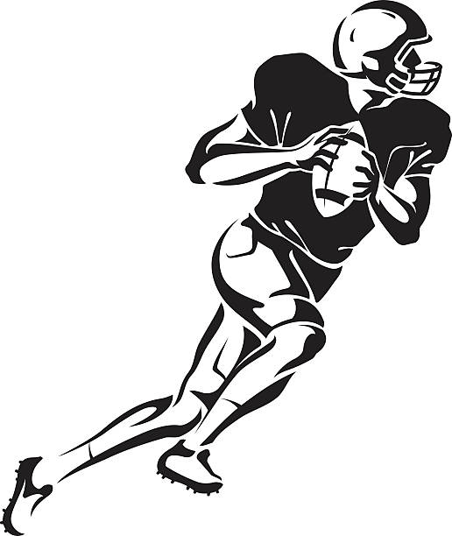
Student Athlete Handbook
2022-2023
Benton Harbor area schools | 870 Colfax Ave Benton Harbor, MI 49022

BENTON HARBOR AREA SCHOOLS
Interim Superintendent, Dr. Kelvin Butts

Developers
Athletic Director, Michael Van Hoven
Athletic Administrative Assistant, Nick Blue

BOARD OF EDUCATION
2022-23
Mrs. Dashuna Robinson, President
Mr. Matthew Bradley, Vice President
Mr. Reinaldo Tripplett, Secretary
Mrs. Angel Crayton, Treasurer
Ms. Lou Buchana, Trustee
Mr. Trenton Bowens, Trustee
Mrs. Stephanie Rockette-Martin, Trustee

Benton Harbor Area Schools maintains a continuing membership with the Michigan High School Athletic Association (MHSAA) and all programs, coaches and athletes are required to adhere to MHSAA rules concerning athletic eligibility and participation. The MHSAA rules have been used to develop this handbook.

Risk of Participation.
By allowing their son/daughter to participate, parent/guardians acknowledge and accept that there is always a risk of serious injury as a result of athletic competition. Benton Harbor Athletic Staff will do everything within their power to minimize any harm to an athlete, but the possibility remains a reality due to the nature of athletic participation.

TO THE STUDENT
Being a member of a Benton Harbor Area Schools athletic team is the fulfillment of an early ambition for many students. The attainment of this goal carries with it certain traditions and responsibilities that must be maintained. A great athletic tradition is not built overnight. It takes hard work from many people over many years to establish. As a member of an interscholastic squad of Benton Harbor Areas Schools, you have inherited a wonderful tradition. A tradition of challenge to uphold.
Benton Harbor Area Schools student athletes desire to win, but only with honor to themselves, our schools and our community. Throughout the years our squads have achieved their share of conference, district, regional, and state tournament championships. We have also had many individuals set records and earn All- Conference as well as All-State honors. It will not be easy to contribute to such an athletic tradition. However, it is worthy of the best efforts of all involved.
By choosing to become a student athlete, you are making a commitment to the many expectations set in place by your family, coaches, peers, mentors, and community. You are choosing to become a role model for your fellow peers and the Benton Harbor students who are much younger than you and who will look up to you and look to you for guidance.
This Athletic Handbook has been designed for two reasons. First, we want to ensure that you and your parent/guardian are aware of the responsibilities involved with being a student athlete. Second, we believe by making this handbook interactive, you will be encouraged to take notes, keep records, and set person and team goals. It is our hope that this handbook play an important role in your athletic career here at Benton Harbor Area School District.
We would like to thank you for your dedication in continuing Benton Harbor’s long history of outstanding athletic programing and opportunities!

BENTON HARBOR SPORTS TEAMS AND SEASONS
BHAS is privileged to offer sporting programs in both middle and high school. Below are lists of sports and their corresponding seasons.

MIDDLE SCHOOL
At the middle school level, sports are offered throughout the entire school year. In middle school there are 4 seasons. School-sponsored sports that are offered are listed below:
Fall Season
Football | Volleyball |  | Sideline Cheer
Winter-1 Season
Boys Basketball |  | Sideline Cheer
Winter-2 Season
Girls Basketball
Spring Season
Boys and Girls Track

HIGH SCHOOL
At the high school level, sports are offered throughout the entire school year. In high school, there are 3 seasons. School-sponsored sports that are offered are listed below:
Fall Season
Cross Country |  | Football |  | Sideline Cheer |  | Volleyball
Winter Season
Boys Basketball |  | Girls Basketball |  | Sideline Cheer |  | Wrestling
Spring Season
Baseball | Boys Golf |  | Boys Track |  | Girls Track |  | Softball

Eligibility

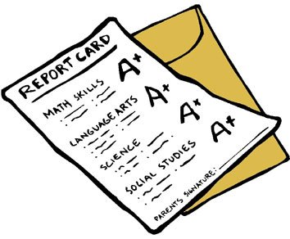

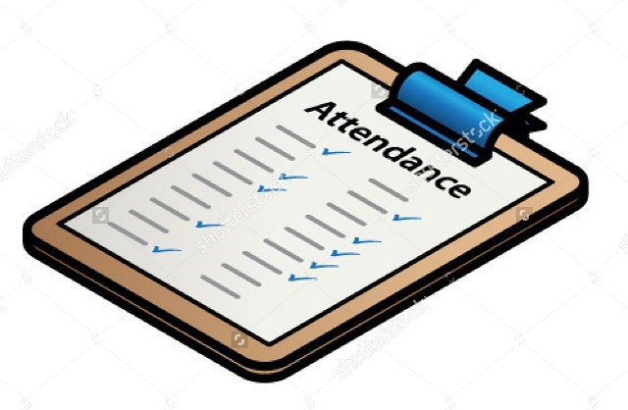

The MHSAA rules and Benton Harbor Area Schools Board policy require that all students must meet eligibility to participate in an athletic contest or scrimmage. Please review the information below:
- You must be enrolled in BHAS and receive credit in 66% or more of your classes based on the high school full time class load. This means, you must pass 4 classes. Passing is defined as a D- or greater, which is usually greater than or equal to a 60%. Grade checks are conducted a minimum of every ten weeks during each quarter. Your athletic director may check grades more often.
- If it is determined that you are ineligible, you will not be able to participate in games or scrimmages until you become eligible. The ineligibility period is one week starting the following Monday. If you continue to be ineligible, the period is extended another week until you become eligible. You should seek assistance from your teacher, counselor, and/or graduation coach to help you with any challenges you are facing.
- You will be allowed to practice during the ineligibility period, provided you conducting yourself in an appropriate manner and you have the head coach’s approval.
- If you are a high school student who have recently enrolled in BHAS, you will be subject to MHSAA rules regarding transfer eligibility. Please see the Athletic Director immediately prior to participating on a team.
“I always felt that my greatest asset was not my physical ability, it was my mental ability.”—Bruce Jenner
- If you join a winter sports team and do not pass 4 classes at the first semester, you will not be eligible to participate in scrimmages or games for the first 12 weeks of the second semester. To become eligible, you must be passing 4 classes at the 12-week mark.
- If you do not pass 4 classes during the spring semester, you will not be eligible to participate in scrimmages or games during the first 12 weeks of the fall semester unless you make up and pass classes during summer school.
- You must always display appropriate citizenship. Disciplinary action as a result of poor conduct may be cause for athletes to lose eligibility. Examples of poor conduct include, but are not limited to, skipping, cheating, fighting, stealing, destruction of school property, sexual harassment, poor citizenship and disrespect.
- You must provide a current copy of your physical that is complete (April 15th or after of each year), signed, and turned into the school office.
Incoming Freshmen and Middle School Students
- If you are an incoming freshman, you are not subject to eligibility rule. You will receive a one-time automatic eligibility for the first semester.
- If you are a middle school student, you must follow the same rules as the high school student athlete. You will have to pass 50 percent of your classes. This means if you have six class you must pass three to be eligible to participate in scrimmages and games.
“It is not true that nice guys finish last. Nice guys are winners before the game even starts.”—Addison Walker
Dual Sport Participation Agreement
While it is unusual, high school athletes may participate in two sports during the same season. To be a dual sport athlete, you must obtain a dual sport contract from the athletic office. Such an agreement requires permissions from the coaches, your parent(s), and the athletic department.
All rules for Middle School eligibility can be found on the Michigan High School Athletic Association website www.mhsaa.com. Regulation 3 Sections 1-7 Pages 83-86)

Take Note

Take a moment to speak with your teachers. Share with them the type of athlete you aspire to be. Ask them for advice for always maintaining good grades. List them here below!

Athletic Guidelines

ATTENDANCE
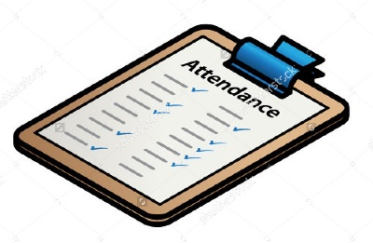
Student success is very important at Benton Harbor Area Schools. Student learning is greatly improved with daily punctual attendance in all classes. As leaders in the school, student athletes are role models in the district which carries responsibility in the school and community. It is this leadership that we always expect from our student athletes by attending classes everyday on time. As a leader, you have the responsibility to model good attendance for your peers. This is what we expect of you:
- Attend class regularly and on time
- Arrive at school every morning on time
- Provide the appropriate documentation when absent
- When receiving a pass from class, complete the task and return promptly
- If you skip classes or fail to be in class on time, your head coach and/or the athletic director may impose a consequence, which could include up to being benched from a game.
- To be able to practice each day or play a game, you are expected to be in class the final 3 periods of the day. If a student athlete cannot be in attendance for the final three hours of the day due to an appointment, the absence must be cleared ahead of time with the coach and athletic director. Written documentation will be required for medical appointments.

Take Note

Talk with your coach, counselor, mentor, or graduation coach to find three ways to help you get to school and class on time. List them here below!
SCHOOL SUSPENSIONS
“I’ve failed over and over and over again in my life. And that is why I succeed.”—Michael Jordan
If you receive out of school suspensions, you are also suspended from all practices, competitions and team activities during your suspension. You are not allowed to attend any sporting or extracurricular event on a Benton Harbor Area School property, even as a spectator. However, if you are assigned in-school suspension, you may be allowed to attend practice but participation in a competition will be determined by the Athletic Director or coach.
EXPLUSIONS
Any student who has been expelled by Benton Harbor Area Schools may not join or practice with a team, nor may they use Benton Harbor Area Schools facilities for training. All students expelled from the district will not be able to enter BHAS Property.

Take Note

Every school takes pride in their athletic programs. As an athlete, you represent the best of Benton Harbor with pride. List three goals for yourself to become the best role model you can be!

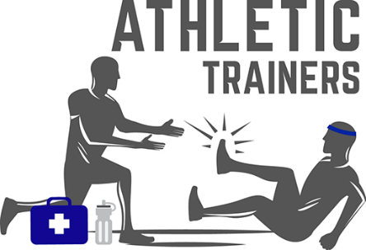
STUDENT WELLNESS
Athletic Injuries
If you are injured, you must report your injuries to the coach and athletic trainer immediately. Benton Harbors athletic trainer is present on a daily basis at the high school and athletes are strongly suggested to consult him with all sports-related injuries. Concussions and other injuries that require ongoing treatment should be brought to a physician if necessary.
Concussions
Head injuries are particularly serious and should be reported to a medical professional as soon as possible. If you are found to have incurred a head injury during the activity, you will be immediately removed from practices or games. If you have concussion like symptoms, this will be reported to the MHSAA by the athletic department staff. If you sustain a concussion will not be allowed to return to practice/games until there are cleared by our trainer and a personal physician.
Information regarding concussions, their symptoms and management will be available to parents and athletes through the athletic department, and is also included in the last page of this handbook. You can also search www.cdc.gov/concussions for additional resources.
Medication
The athletic department and coaches are not allowed to dispense any medication or food supplements. You must follow school procedures for dispensing medications. This will go through the main office and/or student health center.
Alcohol, Tobacco and Drugs
“The more difficult the victory, the greater the happiness in winning.”—Pele
You are required to remain drug-free during their entire athletic career, both in-season and out-of-season. Drug-free means abstaining from the use of alcohol, tobacco, controlled substances and other mind-altering drugs. This includes the abuse of prescription drugs, dietary drugs, other drugs and medications. This also includes steroids or other performance enhancing drugs.
In the interest of promoting honesty and the health of our individual athletes, any student who comes forward to a school official expressing concerns about having an alcohol, tobacco or drug problem will be exempt from disciplinary action. That student will be directed to the Student Health Center for treatment. If treatment is necessary, all prescribed treatment will take precedence over athletic practices and competitions. All recommendations made by the Health Department will have to be met and completed successfully in order for the student to remain eligible for athletics. If a student fails to follow these recommendations through to completion, then he/she will immediately be suspended from participation until his/her treatment is complete.
EXPECTATIONS OF BEING A TEAM MEMBER!
Athletic Equipment Care
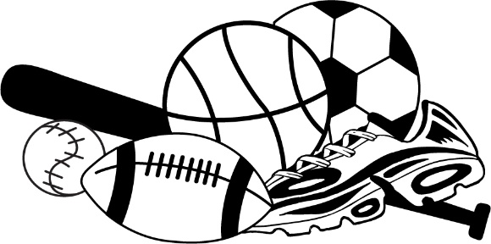
You are responsible for the proper care and security of uniforms and equipment issued to them. School furnished uniforms and equipment may only be used for practice or contests unless expressly approved by the coach. You will be expected to turn in all practice and game uniforms or equipment at the end of the season. If you do not, you will be required to pay cost of replacement. All financial obligations for school equipment must be fully paid to the school before the athlete may compete in another sport and/or be allowed to participate in graduation ceremonies.
Travel & Transportation Expectations
You are expected to travel to, and return from away contests with the team unless prior written approval has been given by both the athletic office and the coaching staff. Your parent/guardian must be listed on your student record in order to travel with them.
While travelling with the team, you must remain with your team and under the supervision of the coach for the duration of the meet or game. Positive, appropriate behavior is required from Benton Harbor Athletes at all times, but especially when representing the school in other schools or communities.
Team Commitment
Participating on a Benton Harbor Area Schools Athletic team is an honor and a privilege which carries responsibly. Please know that with that responsibility comes commitment. You must commit to yourself and your teammates to begin and finish the season. It is strongly encouraged that you see this through until the season ends. If, by chance, there are circumstances to lead you to decide to leave a team during a season, you will not eligible to participate or workout with another team during the same season.
“How am I to know what I can achieve if I quit?”—Jason Bishop
We do realize that circumstances arise which may make it appropriate for a student athlete to leave team during the season. We encourage a student who feels he/she should not be on a team, to talk with their coach and or athletic director to discuss the situation.

Commitment Statement
I, _____________________________ promise to myself and teammates to be the best athlete I can be and to represent Benton Harbor as an athletic ambassador!
Signature |  | Date

Benton Harbor Fight Song
Benton Harbor, on to Victory
Smash right through that line
For we are here to win this contest
Fighting all the time.
Hold high our shield of Orange and Black
We see our banners proudly waving
Fight! Fight! until the last
We're with you, BHHS
We sing of Orange and Black
The colors of our Colfax School.
We sing of Tigers that Fight
So that our colors bright
Shall rule.
We sing of hopes ever high,
Until we know that we have won,
And then we still sing to you.
Oh, Benton Harbor, carry on!

Student Conduct

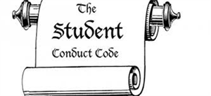

OVERVIEW
Benton Harbor Area School District strongly believes that athletics play an important role in the education of our students. Sports help to teach our students health, life, vocational skills, morality, teamwork and leadership. Sporting events and competitions always involve other schools, their fans, and members of your own community. Your conduct is expected to be exemplary. Participation in extracurricular athletics, while extremely important, is a privilege and is not guaranteed. You are expected to know, understand, and conform to the following athletic code of conduct.
AS A BENTON HARBOR ATHLETE YOU SHOULD:

Do your very best in the classroom and on the playing field to represent yourself, school and the community in a positive manner.

Display exemplary sportsmanship.
-

Respect yourself, your peers, the BHAS staff and the school at all times.

Arrive on time, and attend practices and classes every day.

Promote honesty, and do the right thing even if no one is watching.

Be proud of yourself and your community.

Attend to your health by getting proper rest and being mindful of what you put in your body.

CONDUCT AND CONSEQUENCES
In addition to following the BHAS Student Code of Conduct, student-athletes must also follow the BHAS Athletic Code of Conduct. Student athletes are expected to become familiar with both Codes of Conduct.

Do your very best in the classroom and on the playing field to represent yourself, school and the community in a positive manner.

Arrive on time, and attend practices and classes every day.

EXPECTED CONDUCT | POSSIBLE CONSEQUENCES
Arrive to class on time | Excessive tardies will lead to non-participation for the day, week, or upcoming sporting event.
Provide a valid excuse for absent days | Unexcused absences will lead to non-participation for the day, week, or upcoming sporting event
Arrive to practice on time | Excessive tardies could lead to lost playing time and subject to extra practices
Arrive to games on time and ready to participate | Excessive tardies could result in non-participation of current and future events.
Maintain good grades | Ineligibility will disqualify your participation in any athletic practices or events.
Attend all classes during the day, everyday | Skipping is not permitted. Athletes who are skipping will be marked tardy or absent and not permitted to participate in current events.

Display exemplary sportsmanship.
-
Respect yourself, your peers, the BHAS staff and the school at all times.

EXPECTED CONDUCT | POSSIBLE CONSEQUENCES
Reframe from using vulgar language in school and on the field | Inappropriate language in school will lead to phone calls home, reporting to your coach, in-school suspension or out of school suspension depending upon the severity
Always shake the opponents hand after every win or loss | Unsportsman-like behaviors will lead to non-participation in current and/or future events and could result in additional practice or other restorative practices, i.e. community service
Reframe from losing your temper if you disagree with a decision by coaches, referees and/or officials
Follow all school code of conduct at all times | Depending upon the misconduct, the consequence will follow the BHAS Code of Conduct recommendations
Take direction from all adults at the school and do not argue | Defiance will lead to phone calls home, reporting to your coach, in-school suspension or out of school suspension depending upon the severity
Never engage in physical altercations in or out of school | Fighting during school, outside of school, and/or during a sporting event will lead to BHAS Code of Conduct disciplinary actions
Never bully teammates, classmates, or any individual in school and/or during any athletic events. This includes Cyberbullying. | Bullying during school, outside of school, and/or during a sporting event as well as on-line (Facebook) will lead to BHAS Code of Conduct and/or Athletic Code of Conduct disciplinary actions

Promote honesty, and do the right thing even if no one is watching.

Be proud of yourself and your community.

EXPECTED CONDUCT | POSSIBLE CONSEQUENCES
Speak about your teachers, school, and community in a positive way, always. | Athletic Director and Coaches will be notified and determine the consequences
Make the right choices by not engaging in behaviors in and out of school that could lead to legal problems | Dishonesty and dishonest practices will be reported to the Athletic Director and Coaches. They will determine the consequences. Legal issues may result in non-participation

Take Note

We all find ourselves sometimes unhappy with our friends, family, team, school and/or community. However, we must always understand that our words may carry the wrong message to others who are not involved in situations. List three ways to express your dissatisfaction without offending others verbally, on Facebook, or other social media platforms?

Attend to your health by getting proper rest and being mindful of what you put in your body.

EXPECTED CONDUCT | POSSIBLE CONSEQUENCES
Make every effort to eat balanced meals and reduce the amount of junk food. | Without proper meals, you may not perform well which could lead to injury and playing time.
Make every effort to get the appropriate amount of sleep every night. | Without proper rest, you may not perform well which could lead to injury and playing time.
Report all injuries to the Athletic Trainer or Coach when they occur. | Not reporting injuries will lead to possible suspension from practice and competitions. Additionally, you become more prone to more severe injuries.
Attend to any injury as prescribed by the Athletic Trainer and/or Physician | Failure to follow prescribed treatment will affect participation in practice and/or competitions.
Refrain from using drugs, tobacco, or alcohol at all times. | The use of drugs, tobacco, or alcohol will lead to BHAS Code of Conduct and BHAS Athletic Code of Conduct consequences.
IF YOU DO NOT AGREE WITH THE CONSEQUENCE
Everyone has the right to take time and think about their actions. If you find yourself in a situation that results in being suspended and/or dismissed from an event or team, you have the right to appeal the consequence assigned.

How to Appeal
If you do not agree with the consequence that has been assigned, you and your parent/guardian have the opportunity to file an appeal. Appeals must be filed in writing to the principal or athletic director. Guidelines regarding the appeal process are:

The appeals committee will consist of no less than three school employees, including at least one administrator and one coach. The individual(s) who handed down the original discipline will not be members of the appeals committee. This process is designed to provide you with a fair and unbiased review of the decision and to make a determination to uphold (leave as is) or resend (take away) the original consequence.
“Falling and getting back up is what brings you success.”—Tony Horton
What is a Release of Information Statement?
In the appeals process, committee members will need to review all information relating to the consequence. For this to occur, a release or permissions must be granted from the parent/guardian, if student athlete is not 18 years of age. To obtain this form, visit the athletic office at:
Benton Harbor High School
870 Colfax Avenue
Athletic Office, Room
Benton Harbor, Michigan 49022
The appeal process will be as follows:
All decisions made by the appeals committee are final. The outcome of the appeal will be communicated to the student and parent/guardian within 24 hours. A written statement of the results will be sent to the parent/guardian and coaches, and be on file in the athletic department. Any discipline imposed on an athlete that result from a violation of the general student code of conduct should be appealed to the principal or assistant principal rather than the athletic department, and any changes that result from that appeal will immediately apply to an athlete’s athletic discipline as well.
Deferment of Consequence
Deferment of Consequence means that the consequence may not take immediate affect if you and your parents submit an appeal request and the athletic office is unable to schedule the appeal hearing before the first date of the consequence. For example, if an action that took place on a Monday, the consequence was to NOT participate in Friday’s game, you and your parents submitted an appeal prior to Friday, and the athletic office was unable to schedule the hearing that week, you would be allowed to participate in the Friday game. If the appeal is not overturned, you will not be allowed to participate in the next contest(s), even if the next contest(s) falls in the next season/sport.
“I can accept failure; everyone fails at something. But I cannot accept not trying.”—Michael Jordan
Individual sports programs may reserve the right to add to the guidelines listed above. Any team rules that deviate significantly with a policy outlined in this handbook must be cleared by the athletic director.

awards

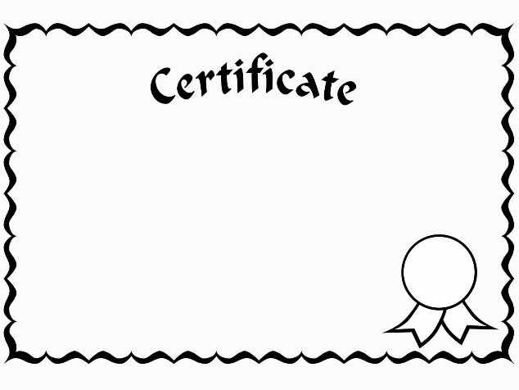

ATHLETIC AWARDS
Receiving an athletic award is not only an accomplishment to be remembered but an honor for your positive representation and contribution to our athletic program. Awards are given to athletes upon recommendation of the coach to the athletic director. Benton Harbor Area Schools’ awards system for athletics follows the guidelines of the Michigan High School Athletic Association.
Awards are as follows:

Use the form on the next page to keep track of your accomplishments. By recording all of the athletic awards you have received, you are building a portfolio that shows your accomplishments and participation in a team environment. Use this information to reflect on your next goals and to have a list available when filling out college and scholarship applications.

Athletic Accomplishments
Sport |  | Award Type |  | School Year

Sports
log

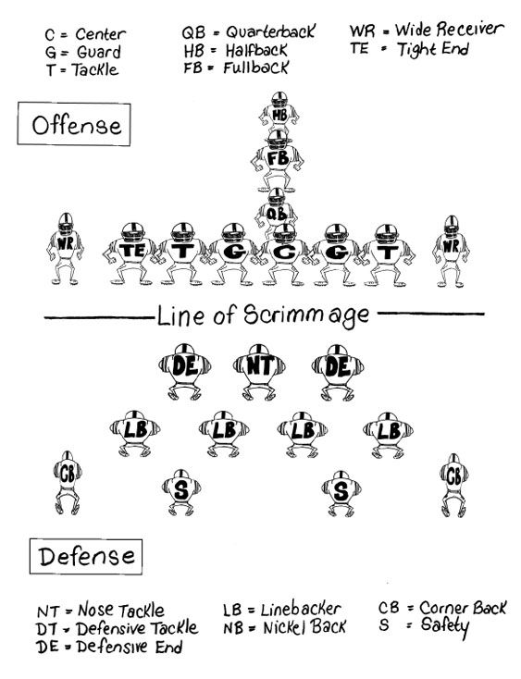
FOOTBALL 101

Scoring Touchdown= 6 points
Field Goal= 3 points
Point After Touchdown= 1 point
Two-Point conversion= 2 points Safety= 2 points
The offense has four attempts, called downs, to move the ball a total of 10 yards. If successful they earn a fresh set of downs. If not the other gets the ball
The attacking team (offense) scores a touchdown by getting the ball into the end zone (the area beyond the goal line)
The ball is either advanced by either the quarterback, throwing to a receiver or a running back carrying the ball

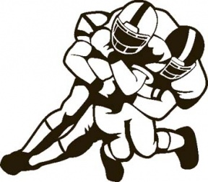
The play ends when the ball carrier is tackled or an unsuccessful pass attempt hits the ground.

Benton Harbor Football Team
Game Date and Opponent: |  |  |  |  |  |  | Position Played: |  |  | Final Score:
OFFENSE | Carries |  |  | Yards |  | Receptions |  |  | Completions |  |  | Touchdowns
DEFENSE | Tackles |  |  | Sacks |  | Fumble Recoveries |  |  | Interception |  |  | TFL

Game Date and Opponent: |  |  |  |  |  |  | Position Played: |  |  | Final Score:
OFFENSE | Carries |  |  | Yards |  | Receptions |  |  | Completions |  |  | Touchdowns
DEFENSE | Tackles |  |  | Sacks |  | Fumble Recoveries |  |  | Interception |  |  | TFL

Game Date and Opponent: |  |  |  |  |  |  | Position Played: |  |  | Final Score:
OFFENSE | Carries |  |  | Yards |  | Receptions |  |  | Completions |  |  | Touchdowns
DEFENSE | Tackles |  |  | Sacks |  | Fumble Recoveries |  |  | Interception |  |  | TFL

Game Date and Opponent: |  |  |  |  |  |  | Position Played: |  |  | Final Score:
OFFENSE | Carries |  |  | Yards |  | Receptions |  |  | Completions |  |  | Touchdowns
DEFENSE | Tackles |  |  | Sacks |  | Fumble Recoveries |  |  | Interception |  |  | TFL

Game Date and Opponent: |  |  |  |  |  |  | Position Played: |  |  | Final Score:
OFFENSE | Carries |  |  | Yards |  | Receptions |  |  | Completions |  |  | Touchdowns
DEFENSE | Tackles |  |  | Sacks |  | Fumble Recoveries |  |  | Interception |  |  | TFL

Game Date and Opponent: |  |  |  |  |  |  | Position Played: |  |  | Final Score:
OFFENSE | Carries |  |  | Yards |  | Receptions |  |  | Completions |  |  | Touchdowns
DEFENSE | Tackles |  |  | Sacks |  | Fumble Recoveries |  |  | Interception |  |  | TFL

Game Date and Opponent: |  |  |  |  |  |  | Position Played: |  |  | Final Score:
OFFENSE | Carries |  |  | Yards |  | Receptions |  |  | Completions |  |  | Touchdowns
DEFENSE | Tackles |  |  | Sacks |  | Fumble Recoveries |  |  | Interception |  |  | TFL

Game Date and Opponent: |  |  |  |  |  |  | Position Played: |  |  | Final Score:
OFFENSE | Carries |  |  | Yards |  | Receptions |  |  | Completions |  |  | Touchdowns
DEFENSE | Tackles |  |  | Sacks |  | Fumble Recoveries |  |  | Interception |  |  | TFL

Game Date and Opponent: |  |  |  |  |  |  | Position Played: |  |  | Final Score:
OFFENSE | Carries |  |  | Yards |  | Receptions |  |  | Completions |  |  | Touchdowns
DEFENSE | Tackles |  |  | Sacks |  | Fumble Recoveries |  |  | Interception |  |  | TFL

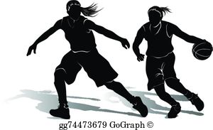
BASKETBALL 101
Ball can only be moved by dribbling or passing.

4 Quarters
8-minute Quarters

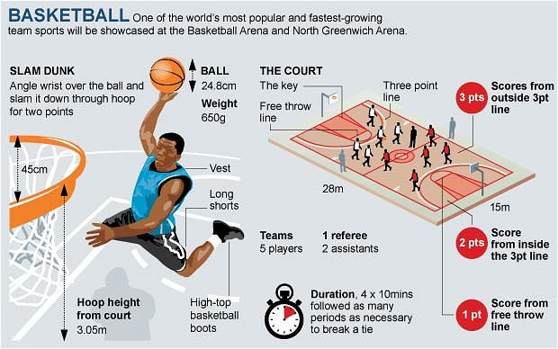

Ball Size
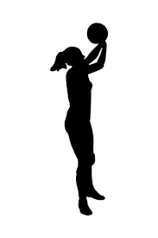

Men’s = 29.5-inch ball

Women’s = 28.5-inch ball
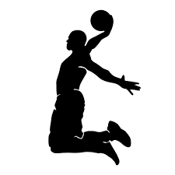
There is no shot clock in high school basketball.

There are 5 positions on the court:
Small Forward
Power Forward
Shooting Guard
Point Guard
Center

After change of possession, the offensive team has 10 seconds to make it across the half-court line.

Violations in basketball include travelling (taking more than one step without bouncing the ball), double dribble (picking the ball up dribbling, stopping then dribbling again with two hands), goaltending (a defensive player interferes with the ball travelling downwards towards the basket) and back court violation (once the ball passes the half way line the offensive team cannot take the ball back over the half way line)

Benton Harbor Basketball Team
Game Date: |  |  | Opponent: |  |  |  |  |  | Position Played: |  |  |  | Final Score
2 pointers |  | 3 pointers |  |  | Free Throws |  |  | Steals |  |  | Rebounds |  |  |  | Assists

Game Date: |  |  | Opponent: |  |  |  |  |  | Position Played: |  |  |  | Final Score
2 pointers |  | 3 pointers |  |  | Free Throws |  |  | Steals |  |  | Rebounds |  |  |  | Assists

Game Date: |  |  | Opponent: |  |  |  |  |  | Position Played: |  |  |  | Final Score
2 pointers |  | 3 pointers |  |  | Free Throws |  |  | Steals |  |  | Rebounds |  |  |  | Assists

Game Date: |  |  | Opponent: |  |  |  |  |  | Position Played: |  |  |  | Final Score
2 pointers |  | 3 pointers |  |  | Free Throws |  |  | Steals |  |  | Rebounds |  |  |  | Assists

Game Date: |  |  | Opponent: |  |  |  |  |  | Position Played: |  |  |  | Final Score
2 pointers |  | 3 pointers |  |  | Free Throws |  |  | Steals |  |  | Rebounds |  |  |  | Assists

Game Date: |  |  | Opponent: |  |  |  |  |  | Position Played: |  |  |  | Final Score
2 pointers |  | 3 pointers |  |  | Free Throws |  |  | Steals |  |  | Rebounds |  |  |  | Assists

Game Date: |  |  | Opponent: |  |  |  |  |  | Position Played: |  |  |  | Final Score
2 pointers |  | 3 pointers |  |  | Free Throws |  |  | Steals |  |  | Rebounds |  |  |  | Assists

Game Date: |  |  | Opponent: |  |  |  |  |  | Position Played: |  |  |  | Final Score
2 pointers |  | 3 pointers |  |  | Free Throws |  |  | Steals |  |  | Rebounds |  |  |  | Assists

Game Date: |  |  | Opponent: |  |  |  |  |  | Position Played: |  |  |  | Final Score
2 pointers |  | 3 pointers |  |  | Free Throws |  |  | Steals |  |  | Rebounds |  |  |  | Assists

Game Date: |  |  | Opponent: |  |  |  |  |  | Position Played: |  |  |  | Final Score
2 pointers |  | 3 pointers |  |  | Free Throws |  |  | Steals |  |  | Rebounds |  |  |  | Assists

Game Date: |  |  | Opponent: |  |  |  |  |  | Position Played: |  |  |  | Final Score
2 pointers |  | 3 pointers |  |  | Free Throws |  |  | Steals |  |  | Rebounds |  |  |  | Assists

Game Date: |  |  | Opponent: |  |  |  |  |  | Position Played: |  |  |  | Final Score
2 pointers |  | 3 pointers |  |  | Free Throws |  |  | Steals |  |  | Rebounds |  |  |  | Assists

Game Date: |  |  | Opponent: |  |  |  |  |  | Position Played: |  |  |  | Final Score
2 pointers |  | 3 pointers |  |  | Free Throws |  |  | Steals |  |  | Rebounds |  |  |  | Assists

Game Date: |  |  | Opponent: |  |  |  |  |  | Position Played: |  |  |  | Final Score
2 pointers |  | 3 pointers |  |  | Free Throws |  |  | Steals |  |  | Rebounds |  |  |  | Assists

Wrestling is a Team Sport and an Individual Sport. Athletes maintain their personal records. Their performance adds to the team performance.

WRESTLING 101

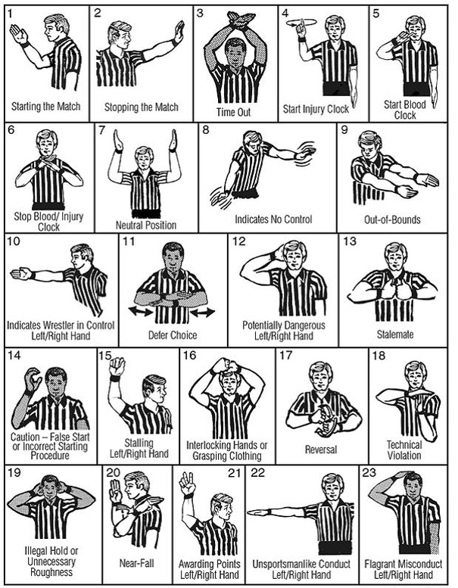

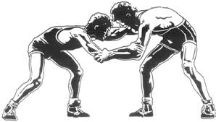

Wrestlers always start their match with a handshake.

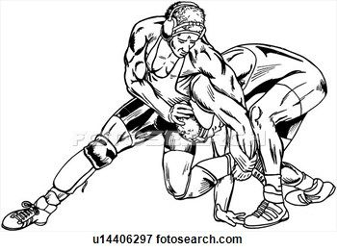

There are 14 Weight Classes:
- 103
- 112
- 120
- 125
- 130
- 135
- 140
- 145
- 152
- 160
- 171
- 189
- 215
- Heavy weight

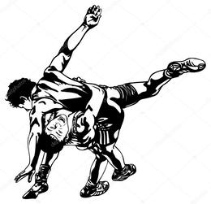
Wrestlers can win their match by points or with a pin.

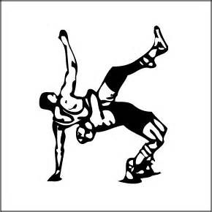

Contests are usual dual meets or tournaments.

Benton Harbor Wrestling Team
Opponent’s Name: |  |  |  |  |  | Opponent’s School:
Weight Class: |  |  |  |  |  |  | Date:
Take Downs |  | Escapes |  | Near Falls |  |  |  | Win/Loss |  |  | By Points |  |  | By Pin (Time)

Opponent’s Name: |  |  |  |  |  | Opponent’s School:
Weight Class: |  |  |  |  |  |  | Date:
Take Downs |  | Escapes |  | Near Falls |  |  |  | Win/Loss |  |  | By Points |  |  | By Pin (Time)

Opponent’s Name: |  |  |  |  |  | Opponent’s School:
Weight Class: |  |  |  |  |  |  | Date:
Take Downs |  | Escapes |  | Near Falls |  |  |  | Win/Loss |  |  | By Points |  |  | By Pin (Time)

Opponent’s Name: |  |  |  |  |  | Opponent’s School:
Weight Class: |  |  |  |  |  |  | Date:
Take Downs |  | Escapes |  | Near Falls |  |  |  | Win/Loss |  |  | By Points |  |  | By Pin (Time)

Opponent’s Name: |  |  |  |  |  | Opponent’s School:
Weight Class: |  |  |  |  |  |  | Date:
Take Downs |  | Escapes |  | Near Falls |  |  |  | Win/Loss |  |  | By Points |  |  | By Pin (Time)

Opponent’s Name: |  |  |  |  |  | Opponent’s School:
Weight Class: |  |  |  |  |  |  | Date:
Take Downs |  | Escapes |  | Near Falls |  |  |  | Win/Loss |  |  | By Points |  |  | By Pin (Time)

Opponent’s Name: |  |  |  |  |  | Opponent’s School:
Weight Class: |  |  |  |  |  |  | Date:
Take Downs |  | Escapes |  | Near Falls |  |  |  | Win/Loss |  |  | By Points |  |  | By Pin (Time)

Opponent’s Name: |  |  |  |  |  | Opponent’s School:
Weight Class: |  |  |  |  |  |  | Date:
Take Downs |  | Escapes |  | Near Falls |  |  |  | Win/Loss |  |  | By Points |  |  | By Pin (Time)

Opponent’s Name: |  |  |  |  |  | Opponent’s School:
Weight Class: |  |  |  |  |  |  | Date:
Take Downs |  | Escapes |  | Near Falls |  |  |  | Win/Loss |  |  | By Points |  |  | By Pin (Time)

Opponent’s Name: |  |  |  |  |  | Opponent’s School:
Weight Class: |  |  |  |  |  |  | Date:
Take Downs |  | Escapes |  | Near Falls |  |  |  | Win/Loss |  |  | By Points |  |  | By Pin (Time)

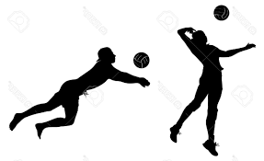
VOLLEYBALL 101
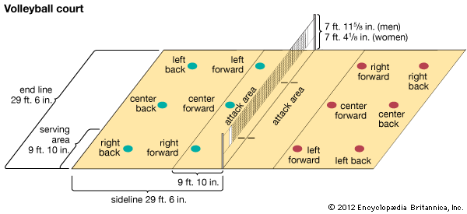

Volleyball is a fast-paced sport. Players must be quick on their feet, agile, and strong. Volleyball requires players to have the ability to continuously move, jump, and dive.

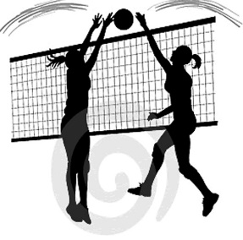
Blocking
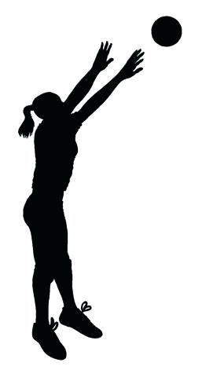
Block solos, block assists, blocking errors
Setting
Assists, ball handling errors
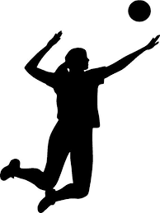
6 players are on the court at one time. Three in the front row and three in the back row.

Attacking
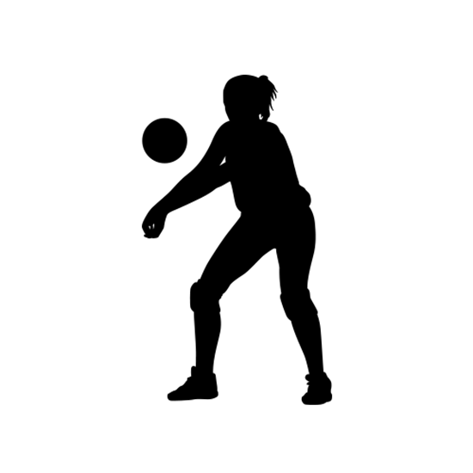
Kills, errors, total attacks, hitting percentage
There are lots of rules that require more than one person to make calls. There are two Referees and Two Line Judges

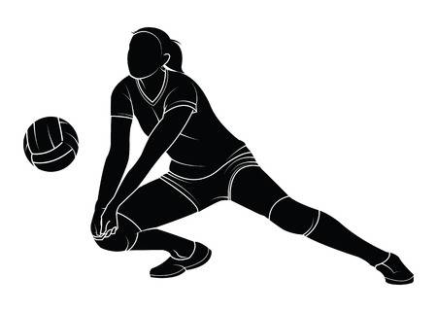
Passing
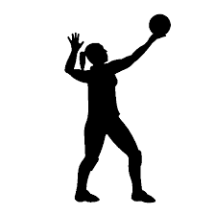
Defense
Reception errors, reception attempts
Digs
Serving

A ball can only be hit a maximum of 3 times when in possession by a team. A player may not hit the ball twice in a row.
Service aces, serve attempts

Benton Harbor Volleyball Team
Opponent: |  |  |  |  |  |  |  |  | Position Played |  |  |  |  |  |  |  |  | Date:
Score 1 |  |  |  | Score 2 |  |  |  | Score 3 |  | Score 4 |  |  |  | Score 5 |  |  |  |  | Match:
Attacks |  |  |  |  | Setting |  |  | Serving |  | Passing |  |  |  |  | Defense |  |  |  |  | Blocking

Opponent: |  |  |  |  |  |  |  |  | Position Played |  |  |  |  |  |  |  |  | Date:
Score 1 |  |  |  | Score 2 |  |  |  | Score 3 |  | Score 4 |  |  |  | Score 5 |  |  |  |  | Match:
Attacks |  |  |  |  | Setting |  |  | Serving |  | Passing |  |  |  |  | Defense |  |  |  |  | Blocking

Opponent: |  |  |  |  |  |  |  |  | Position Played |  |  |  |  |  |  |  |  | Date:
Score 1 |  |  |  | Score 2 |  |  |  | Score 3 |  | Score 4 |  |  |  | Score 5 |  |  |  |  | Match:
Attacks |  |  |  |  | Setting |  |  | Serving |  | Passing |  |  |  |  | Defense |  |  |  |  | Blocking

Opponent: |  |  |  |  |  |  |  |  | Position Played |  |  |  |  |  |  |  |  | Date:
Score 1 |  |  |  | Score 2 |  |  |  | Score 3 |  | Score 4 |  |  |  | Score 5 |  |  |  |  | Match:
Attacks |  |  |  |  | Setting |  |  | Serving |  | Passing |  |  |  |  | Defense |  |  |  |  | Blocking

Opponent: |  |  |  |  |  |  |  |  | Position Played |  |  |  |  |  |  |  |  | Date:
Score 1 |  |  |  | Score 2 |  |  |  | Score 3 |  | Score 4 |  |  |  | Score 5 |  |  |  |  | Match:
Attacks |  |  |  |  | Setting |  |  | Serving |  | Passing |  |  |  |  | Defense |  |  |  |  | Blocking

Opponent: |  |  |  |  |  |  |  |  | Position Played |  |  |  |  |  |  |  |  | Date:
Score 1 |  |  |  | Score 2 |  |  |  | Score 3 |  | Score 4 |  |  |  | Score 5 |  |  |  |  | Match:
Attacks |  |  |  |  | Setting |  |  | Serving |  | Passing |  |  |  |  | Defense |  |  |  |  | Blocking

Opponent: |  |  |  |  |  |  |  |  | Position Played |  |  |  |  |  |  |  |  | Date:
Score 1 |  |  |  | Score 2 |  |  |  | Score 3 |  | Score 4 |  |  |  | Score 5 |  |  |  |  | Match:
Attacks |  |  |  |  | Setting |  |  | Serving |  | Passing |  |  |  |  | Defense |  |  |  |  | Blocking

Opponent: |  |  |  |  |  |  |  |  | Position Played |  |  |  |  |  |  |  |  | Date:
Score 1 |  |  |  | Score 2 |  |  |  | Score 3 |  | Score 4 |  |  |  | Score 5 |  |  |  |  | Match:
Attacks |  |  |  |  | Setting |  |  | Serving |  | Passing |  |  |  |  | Defense |  |  |  |  | Blocking

Opponent: |  |  |  |  |  |  |  |  | Position Played |  |  |  |  |  |  |  |  | Date:
Score 1 |  |  |  | Score 2 |  |  |  | Score 3 |  | Score 4 |  |  |  | Score 5 |  |  |  |  | Match:
Attacks |  |  |  |  | Setting |  |  | Serving |  | Passing |  |  |  |  | Defense |  |  |  |  | Blocking

Opponent: |  |  |  |  |  |  |  |  | Position Played |  |  |  |  |  |  |  |  | Date:
Score 1 |  |  |  | Score 2 |  |  |  | Score 3 |  | Score 4 |  |  |  | Score 5 |  |  |  |  | Match:
Attacks |  |  |  |  | Setting |  |  | Serving |  | Passing |  |  |  |  | Defense |  |  |  |  | Blocking

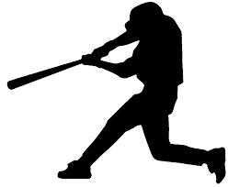
BASEBALL 101

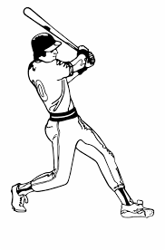
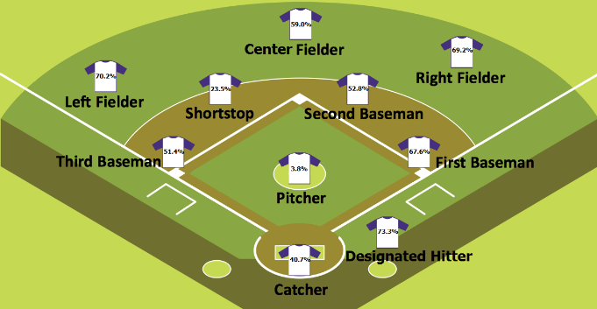

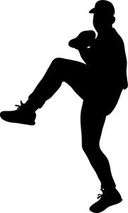

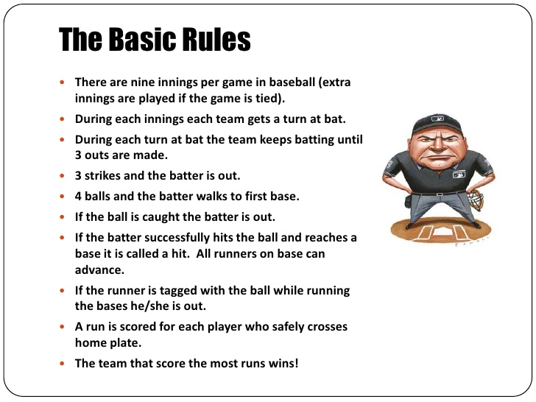

7 innings in High School Baseball

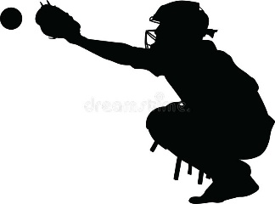
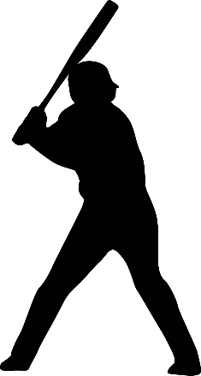
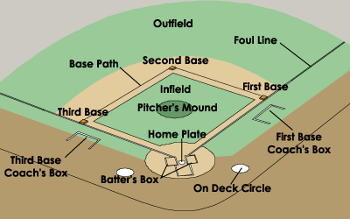
Benton Harbor Baseball Team
Game Date |  | Opponent |  | (H) Home or (A) Away |  | Final Score
 |  |  |  |  |  | BHHS |  | Opponent
Basketball Highlights

SOFTBALL 101
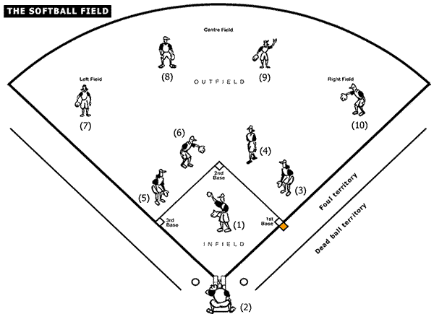

Softball and Baseball are very similar in many ways! All of the positions are the same and scoring is the same. There are three noticeable differences, the size of field, the size of the ball and the pitching style.

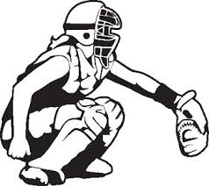
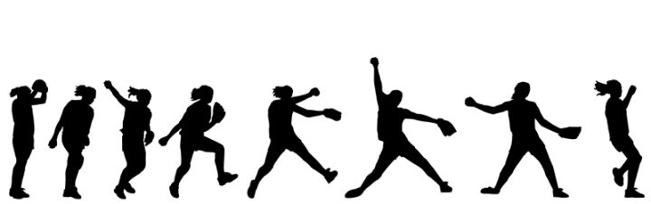
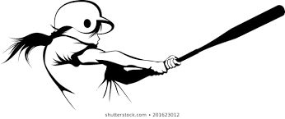
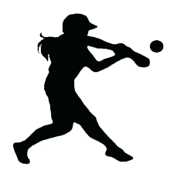
Fast Pitch
Bats cannot be longer than 34’ and the barrel may not be more than 2 ¼ inches in diameter at its widest. The bat cannot exceed 31.5 ounces.

Bat Rules
What makes softball so unique is the pitching style. This style is an underhand throwing technique with tremendous speed

Baseball = 9-inch ball
Softball = 12-inch ball
Ball Size
Benton Harbor Softball Team
Game Date |  | Opponent |  | (H) Home or (A) Away |  | Final Score
 |  |  |  |  |  | BHHS |  | Opponent
Baseball Highlights

TRACK & FIELD 101
TRACK EVENTS
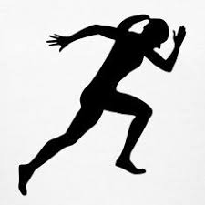
A Track and Field event is called a “Meet.” This sport represents both individual and team experiences. It is the most diversified sport in our high school sporting programs. Participants have the opportunity to compete in various events and win multiple places.

MIDDLE DISTANCE
800 meters
DISTANCE
1600 meters
3200 meters

SPRINTS
100 meters
200 meters
400 meters

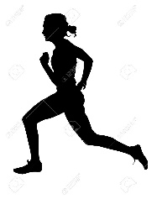
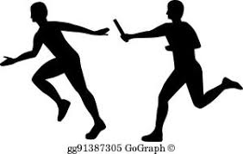

RELAYS
4 x 100 meters
4 x 200 meters
4 x 400 meters
4 x 800 meters

FIELD EVENTS
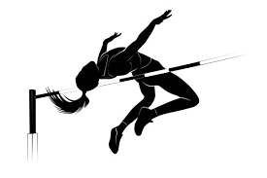
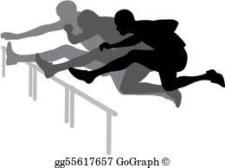
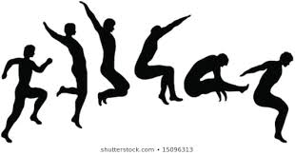
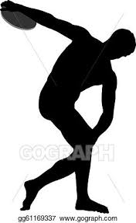
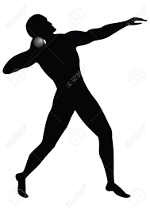
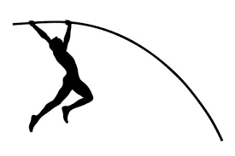
VERTICAL JUMPS
High Jump
Pole Vault
HURDLES
100-110 meters
300 meters
THROWS
Discus
Shot Put
HORIZONTAL JUMPS
Long Jump

Benton Harbor Track & Field Team
Meet Date |  | Opponent |  | Event |  | Time |  | Distance/Height |  | Place

CROSS COUNTRY 101

Conditioning
Conditioning happens by running mileage, usually athletes start in the summer. Athletes mix running and sprinting.

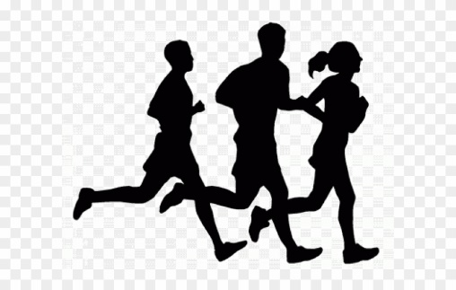

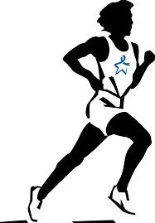
Conditioning also involves a combination of running 2 minutes then sprinting 30 seconds, Repeat, Repeat, Repeat, for example.

Distance
5 Kilometers or 3.1 miles
Scoring
Top 5 runners in a race score for the team
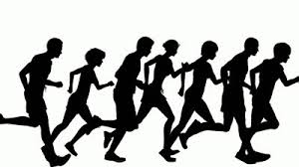

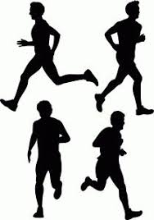
Strategy
Take the top 6 on your team. Strategy is to beat the person on the opposing team that corresponds with the rank on our own team

Perfect Score
Top 5 runners taking the first five places!
Benton Harbor Cross Country Team

Meet Date |  | Opponent |  | Time |  | Place |  | Final Score

Technical Dancing
SIDELINE CHEER 101

Cheerleading has become a competitive sport over the past 15 years. Many cheerleaders possess skills beyond chanting. Now-a-days, cheerleaders can earn scholarships to colleges and universities. Here are some of the skills that are often mastered:

Power Tumbling
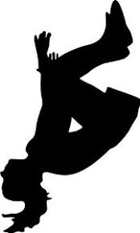

Gymnastics

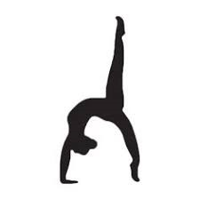
Strength & Control
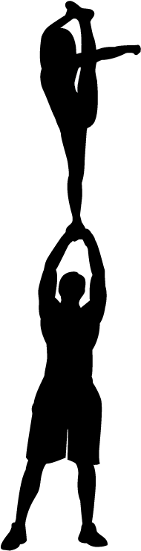

Cheer Squads are the leaders in our school to support school spirit. Cheerleaders should know all of the details of the sports they cheering for, names of players and coaches, and serve as ambassadors for home and away games and competitions.
Here are some of the difficult skills cheerleaders do:

Toe Touch

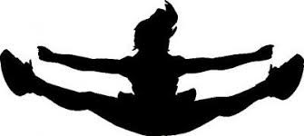
Bow & Arrow

Scorpion
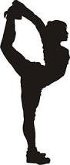
Splits
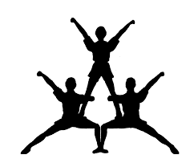

Heel Stretch
Pyramid
Benton Harbor Cheerleading Squad

Personal Accomplishments: |  | Date:

GOLF 101
Stroke Play
The player with the least number of strokes required to complete the course is considered the winner.
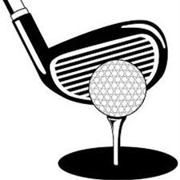
Scoring System
Double Eagle or Albatross
A score of 3 strokes under par
Eagle
A score of 2 strokes under par on a hole
Birdie
A score of 1 stroke under par on a hole
Par
A score of no strokes over or under par on a hole
Bogey
A score of 1 stroke over par on a hole
Double Boogie
A score of 2 strokes over par on a hole

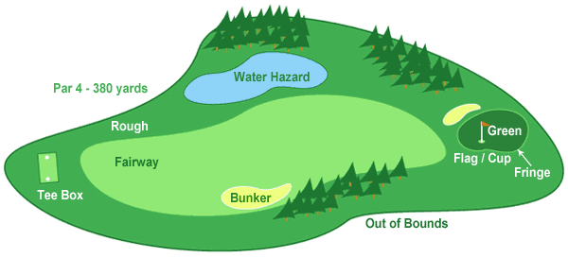

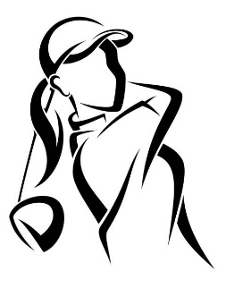
Golfing Etiquette
Good etiquette and sportsmanship on the course always include:
- Never throwing your clubs
- Repairing holes that you make (this is called a Divot)
- Treating the green with delicate respect, i.e. never place your bag on the green
- Raking the sand after you leave the bunker
- Waiting until the coast is clear before hitting your ball
- Yell “Fore” when you think your ball might hit another golfer

Course Type
Par 3
Usually 200 yards
Par 4
Usually 200-450 yards
Par 5
Usually 450-650 yards

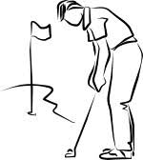

Benton Harbor Golf Team
Opponent: |  |  |  |  |  |  |  | Date:
Hole |  | 1 | 2 | 3 | 4 | 5 | 6 |  | 7 |  | 8 | 9
Par
Length |  |  |  |  |  |  |  |  |  |  |  |  | Total

Opponent: |  |  |  |  |  |  |  | Date:
Hole |  | 1 | 2 | 3 | 4 | 5 | 6 |  | 7 |  | 8 | 9
Par
Length |  |  |  |  |  |  |  |  |  |  |  |  | Total

Opponent: |  |  |  |  |  |  |  | Date:
Hole |  | 1 | 2 | 3 | 4 | 5 | 6 |  | 7 |  | 8 | 9
Par
Length |  |  |  |  |  |  |  |  |  |  |  |  | Total

Opponent: |  |  |  |  |  |  |  | Date:
Hole |  | 1 | 2 | 3 | 4 | 5 | 6 |  | 7 |  | 8 | 9
Par
Length |  |  |  |  |  |  |  |  |  |  |  |  | Total

Opponent: |  |  |  |  |  |  |  | Date:
Hole |  | 1 | 2 | 3 | 4 | 5 | 6 |  | 7 |  | 8 | 9
Par
Length |  |  |  |  |  |  |  |  |  |  |  |  | Total

Opponent: |  |  |  |  |  |  |  | Date:
Hole |  | 1 | 2 | 3 | 4 | 5 | 6 |  | 7 |  | 8 | 9
Par
Length |  |  |  |  |  |  |  |  |  |  |  |  | Total

Opponent: |  |  |  |  |  |  |  | Date:
Hole |  | 1 | 2 | 3 | 4 | 5 | 6 |  | 7 |  | 8 | 9
Par
Length |  |  |  |  |  |  |  |  |  |  |  |  | Total

TO THE PARENTS/GUARDIANS
Positive parental involvement in school athletics is vital to your athlete’s success. To help stress the importance of this involvement, we have developed a set of guidelines to remind parents of some of the key areas of importance. The following are commitment guidelines for parents who have students participating in interscholastic competition.
Transportation
Students are required to ride the district-provided transportation to and from events. Exceptions are made through pre-arrangement with the coach and Athletic Director. Please pick up athletes within 15 minutes after completion of practices or contests.
Volunteering
Concession stand coverage is needed at every event. The concession area depends on volunteers like you. If you are interested, please contact the athletic office. Money raised by the concessions goes to benefit and offset cost of athletic equipment and supplies.
Sportsmanship
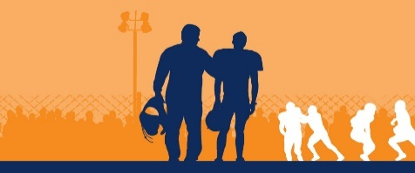
Modeling proper behavior is vital for our athletes to witness. It is our goal to develop sportsmanship in each of our athletes. Parents are expected to talk to their student about their behavior at practice and before, during, and after athletic events. Eliminating poor sportsmanship at games has been an important goal of the MHSAA and Benton Harbor Athletic Department. Please help us to maintain positive sportsmanship at all times!
24 Hour Rule/Communication
Proper and timely communication between parents and coaches can help eliminate most, if not all, misunderstandings and conflict that might occur. Should you need to discuss a situation, please contact the coach to set up a meeting. After games, we ask that parents/guardians wait until the next business day to talk with a coach. Most times, immediately after a game is not the best time to have a discussion, especially when a concern may be highly emotional. Our coaches have many duties after a game including post-game talks, clean up, uniform collection and supervision of our student athletes. It is best to contact the coach the next day to set up an agreed upon time and have that conversation with no distractions for neither you or the coach. This will allow both of you to have time to better assess a possible emotion situation. Setting up the meeting may take place before 24 hours.

Support of Coach/Parents
Many times coaches and parents are not in agreement with decisions with program management, team rules, playing time and overall philosophy of the program. It is vital that we let the coaches do their jobs and coach. Modeling the respect for the coach in front of students is very important. Please support the coach’s decisions about discipline and team policies which may affect your athlete’s playing time. It is difficult to always please everyone. However, if we support our coaches, the student athletes will benefit with a very positive educational athletic experience

STUDENT/ATHLETE HANDBOOK
Cut Along Dotted Line
ACKNOWLEDGEMENT FORM

I have read the Student/Athlete Handbook and understand the rules and policies, which regulate athletics in Benton Harbor Area Schools. I agree to abide by these rules and policies and understand that if I violate them, I am subject to disciplinary actions. I also understand that my coach may have additional rules and policies for which I am responsible.
I understand that the athletic activities offered by Benton Harbor Area Schools require dedication, hard work and strenuous athletic exertion. I understand that those who participate in athletics are exposed to the risk of injury including serious permanent injury.

 | ATHLETE’S SIGNATURE |  | DATE
 | PARENT’S SIGNATURE |  | DATE
Cut Along Dotted Line

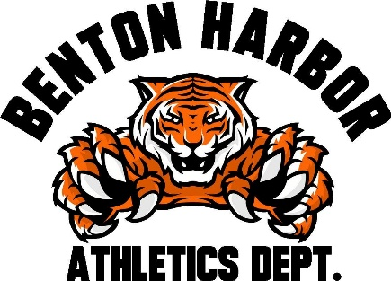

Benton Harbor High School
Interim Principal- Dr. Ryan Gobles
Athletic Director- Michael Van Hoven
269-605-1245
Administrative Assistant- Nick Blue
269-605-1241
www.bhas.org

